Habib University

CS 101 – Programming Fundamentals

Fall 2022

**Lab# 01**

**Hour of Code and Introduction to Python**

**Hour of Code**

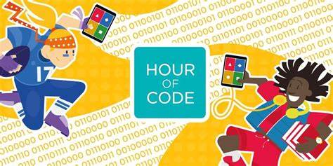

The Hour of Code started as a one-hour introduction to computer science, designed to demystify "code", to show that anybody can learn the basics, and to broaden participation in the field of computer science.

Let’s start the Hour of Code Activity.

Beginner (B) Track:

[Moana: Wayfinding with Code](https://hourofcode.com/moana)

[Outbreak Simulator](https://hourofcode.com/ob)

Experienced (E) Track:

[Mario's Secret Adventure](https://hourofcode.com/hatchmario)

[Debugger](https://hourofcode.com/tynkerd)

**What is Python?**

Python is very simple, yet incredibly powerful programming language. You can use it for writing web and desktop applications, do scientific computations, create scripts, and more. You can use Python for almost anything.

**Programming in Interactive Mode**

We will be using Visual Studio Code’s integrated terminal to run python in interactive mode.

Open Visual Studio Code. Following screen will appear.

Open Visual Studio Code’s Integrated Terminal.

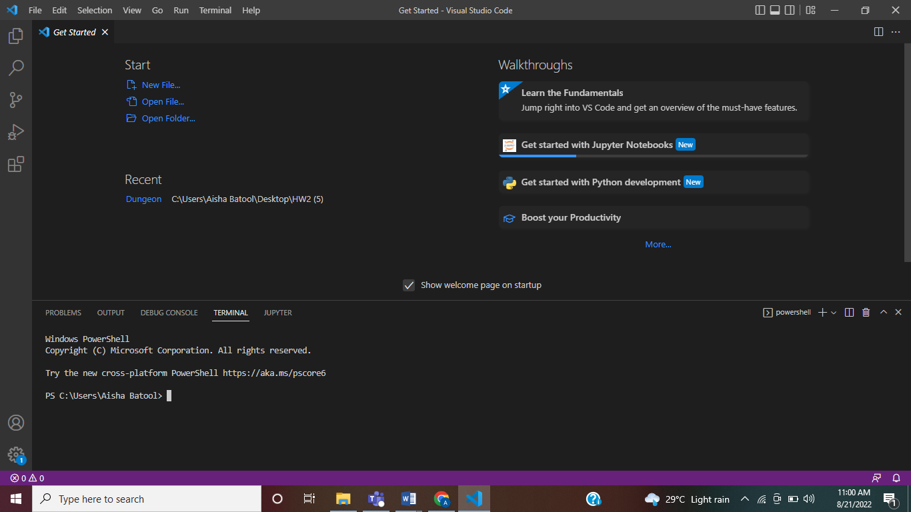

For Windows, type python on terminal.

For MAC OS, type python3 on terminal.

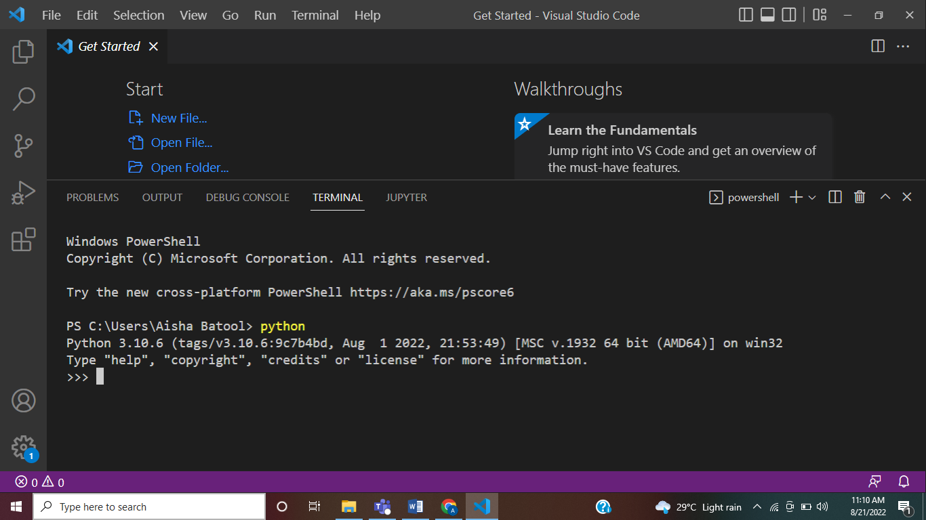

The screen you see now is an interactive mode for running python code. The last line (>>) is a prompt that indicates that the interpreter is ready for you to enter code. Statements typed in interactive mode are not saved as a program.

**Python as a Calculator**

The ability to perform different arithmetic and Boolean (comparison) operations lays at the very foundation of Programming.

The following is a list of some of the basic arithmetic operators:

|  |  |
| --- | --- |
| + | Addition |
| - | Subtraction |
| * | Multiplication |
| / | Division |
| // | Floor Division (rounds down non-integer results to a integer) |
| ** | Exponent |
| % | Modulus (Gives the remainder of a division) |

Try some of these out!

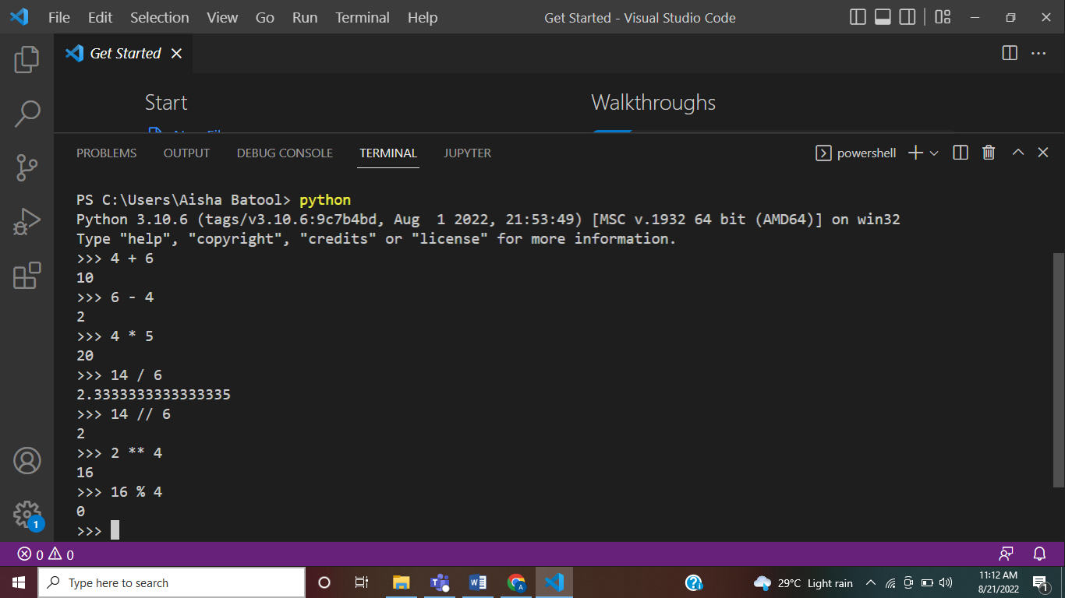

**EXERCISE# 1**

**What will be the result of the following?**

**a) 84 / 2**

**b) 6**2 + 6**

**c) 2 / 5**

**d) 2.0 / 5.0**

**e) (2+5) ** (5-2)**

The usual order of operations (PEDMAS) is followed by the interpreter. (Parenthesis-Exponentiation-Division-Multiplication-Addition-Subraction).

1. Expressions in parenthesis are evaluated first, followed by the exponentiation operation.
2. Division and Multiplication are evaluated next and have the same order.
3. Operations of the same order are evaluated left to right.
4. Addition and Subtraction have the same order.

**EXERCISE# 2**

**What will be the result of the following?**

**a) 3 * (2-2)**

**b) (2+1) * (4/2)**

**c) 3**2 + 1**

**d) 2.0 / 2.0 / 2.0**

**Data Types**

A value is one of the basic things a program works with, like a letter or a number. Some values we have seen so far are 2, 42.0, and 'Hello, World!'. These values belong to different types.

The following is a list of some basic data types:

|  |  |  |
| --- | --- | --- |
| Integers | int | A numeric data type for storage and operations on integer numbers. |
| Floating Point | float | A numeric data type for storage of decimal numbers. |
| String | str | A character based data type used for storage of a stream of characters. |
| Boolean | bool | A logic based data type used for storing truth values: True or False. |

If you are not sure what type a value has, the interpreter can tell you:

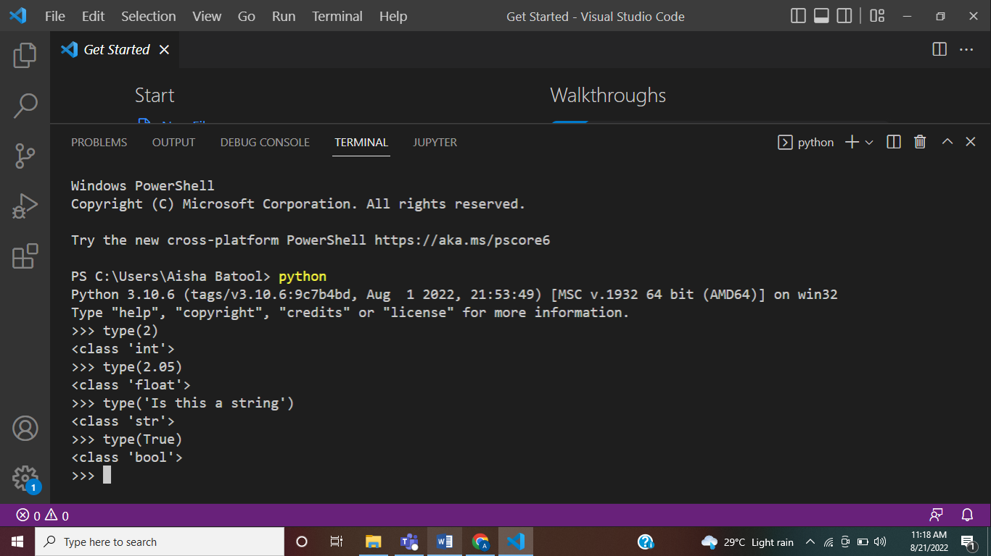

**EXERCISE# 3**

**What will be the result of the following?**

**a) type(5)**

**b) type(42.0)**

**c) type(‘2.0’)**

**d) type(‘42.0’)**

**e) type(“2.0”)**

**f) type(“Hello”)**

Anything in single or double quotation marks is a string. You can easily convert a string into:

1. an integer using the operation **int(*insert expression*)**
2. a float using the operation **float(*insert expression*)**

Similarly, you can convert float or integer using: **str(*insert expression*)**

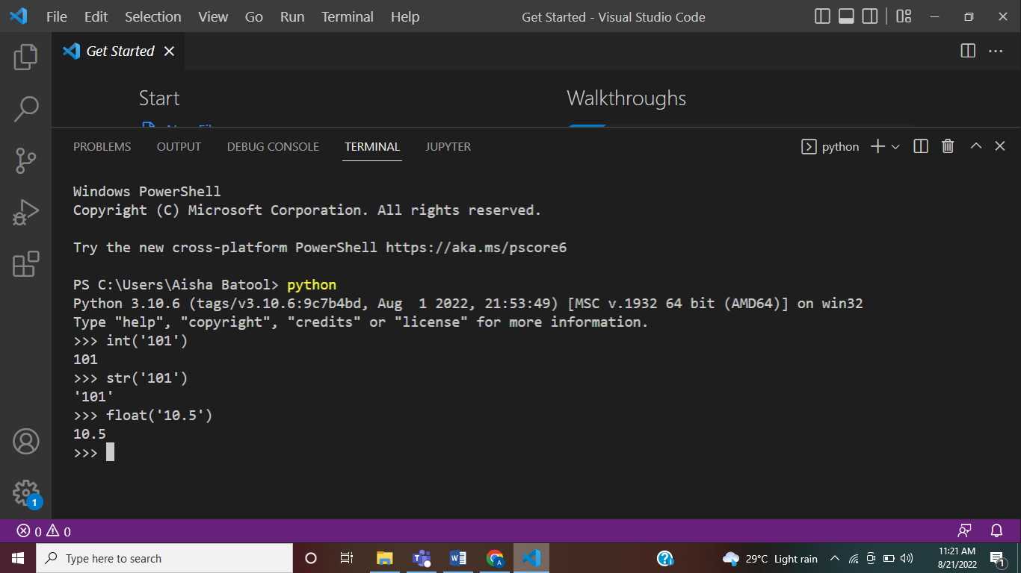

**EXERCISE# 4**

**Do the following conversions by using Python:**

**a) Convert 5 to string.**

**b) Convert 42.0 to string.**

**c) Convert “5” to integer.**

**d) Convert ‘2.0’ to float.**

**The Print Statement**

A long-held belief in the programming world has been that printing a “Hello, World!” message to the screen as your first program in a new language will bring you luck. In Python, you can write the ‘Hello World’ program in a single line:

print("Hello, World!")

We can also use \n to add a new line inside a single print statement.

print('This is your first program.\nHappy Programming!')

To add space between two strings, you can use comma ‘,’ between two strings.

print('This is your first program.', 'Happy Programming!')

To add two strings without space, add ‘+’ sign.

print('This is your first program.' + ' Happy Programming!')

We can use the print statement to print numbers as well.

print(5)

We can also print the result of an arithmetic operation between two integers.

print(25*4)

You can also print string and numbers together in a single print statement.

print("You are Number#", 1)

You can also multiply a string with a number. Let’s try and see what will happen! 😊

print("a" * 5)

**EXERCISE# 5**

1. **Print “Hello, Python!” on the screen.**